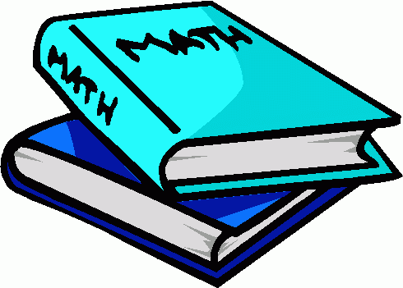
Name
Comparing Fractions

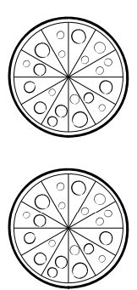
Directions: Shade in the fractions on each pizza. Then write the correct sign (<,>,=).

1.)

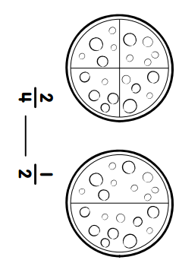
2.)

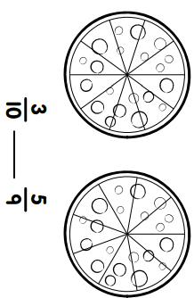
3.)

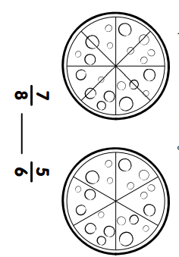

4.)

5.) Jimmy is at the pizza place and wants to pick out 1 slice of pizza. The first pizza pie is cut into 4 slices. The second pizza pie is cut into 12 slices. Jimmy wants the biggest piece of pizza he can get. Should he choose a piece from the first pizza pie or second pizza pie? Draw pictures to model your answer.

Jimmy should choose a piece of pizza from the pizza pie.
Write the correct comparison symbol (<,>,=) in each box. You may use your fraction kits and draw models to help you.

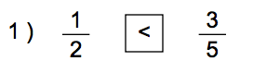

Draw example here before making copies.

